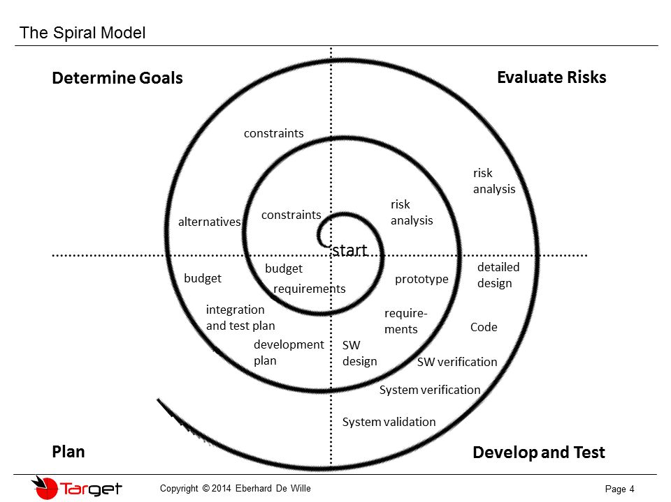

see file

BUDGET REQUIREMENTS

CONSTRAINTS  
 Release Date –

RISK ANALYSIS  
 Project is n% of our grade

PROTOTYPE

REQUIREMENTS  
 see file:

SOFTWARE DESIGN

DEVELOPMENT PLAN

INTEGRATION AND TEST PLAN  
 Each feature/module should have a list of tests to show it worked  
 and to show subsequent features do not break anything

BUDGET  
 0$  
 four developers  
 three months

ALTERNATIVES

CONSTRAINTS

RISK ANALYSIS  
 Adding “one more additional feature” is not as important as having the core application  
working flawlessly

DETAILED DESIGN  
  
  
CODE

SOFTWARE VERIFICATION

SYSTEM VERIFICATION

SYSTEM VALIDATION